产品名称：Gate station
产品型号：IZM-212CS4-IPM
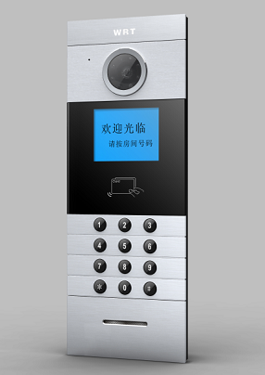
产品特点：
Features:
1. Suit for the Elite series security R2 system.
2.Max capacity is 1016 door phone；
3. Color video；
4. 4. 0"LCD Display；
5. Soft coding form, it is freed from building structure；
6. Fashion keyboard with button, dust proof, long service life（optional）；
7. Can call /talk to Guard Center with remote unlock.
8. Unlock by password or cards（optional）；
9. Picture snap function（optional）。
10. Burglar alarm（optional）；
11. Door magnet alarm；
12. Lift call function（optional）；
13. CCD with night infrared compensation；
14. TCP/ IP Agreement, network, remote system upgrade
技术参数：
Specification:
Direct Voltage- - - - - - - - - - - - - - - - - - - - - - - - - +18VDC
Standby Current- - - - - - - - - - - - - - - - - - - - - - - -≤300 m A
Working Current- - - - - - - - - - - - - - - - - - - - - - - -≤380 m A
Operating Temperature- - - - - - - - - - - - - - - - - - - - 3 0 C～+ 5 5 C
Humidity- - - - - - - - - - - - - - - - - - - - - - - - - - - - - 4 5 %～9 5 %
Distortion- - - - - - - - - - - - - - - - - - - - - - - -- - - - -≤5 %
Sensitivity- - - - - - - - - - - - - - - - - - - - - - - - - - - - ≤3 0 m V
Camera- - - - - - - - - - - - - - - - - - - - - - - - - -5 - 1 6 U . 5 0 0 wire. Automatic backlight compensation
Signal System- - - - - - - - - - - - - - - - - - - - - - - -- - - PAL
Resolution- - - - - - - - - - - - - - - - - - - - - - - - - - - - -3 2 0（R G B ) x 2 4 0
LCD- - - - - - - - - - - - - - - - - - - - - - - -- - - - - - - - - -4. 0 inch
Conversation Time- - - - - - - - - - - - - - - - - - - - - - - -About 60 seconds
Network port- - - - - - - - - - - - - - - - - - - - - - - - - - - - - RJ45
Way of Transmission- - - - - - - - - - - - - - - - - - - - - - - -TCP/IP
Transmission distance- - - - - - - - - - - - - - - - - - - - - For details, read the requirement of wire size
IC Access Time- - - - - - - - - - - - - - - - - - - - - - - -- - -＜100 m s
IC Access Distance- - - - - - - - - - - - - - - - - - - - - - - -≤2 0 m m
Capacity of cards- - - - - - - - - - - - - - - - - - - - - - - - - - -3000
Defence Grade- - - - - - - - - - - - - - - - - - - - - - - -- - - - -IP33
External Dimensions- - - - - - - - - - - - - - - - - - - - - - - -147×393×80mm（Including bottom case）
Size of Bottom case- - - - - - - - - - - - - - - - - - - - - - - -- 133×377×65mm

