Indoor monitor
Model No.A7S-801ZCD8S7

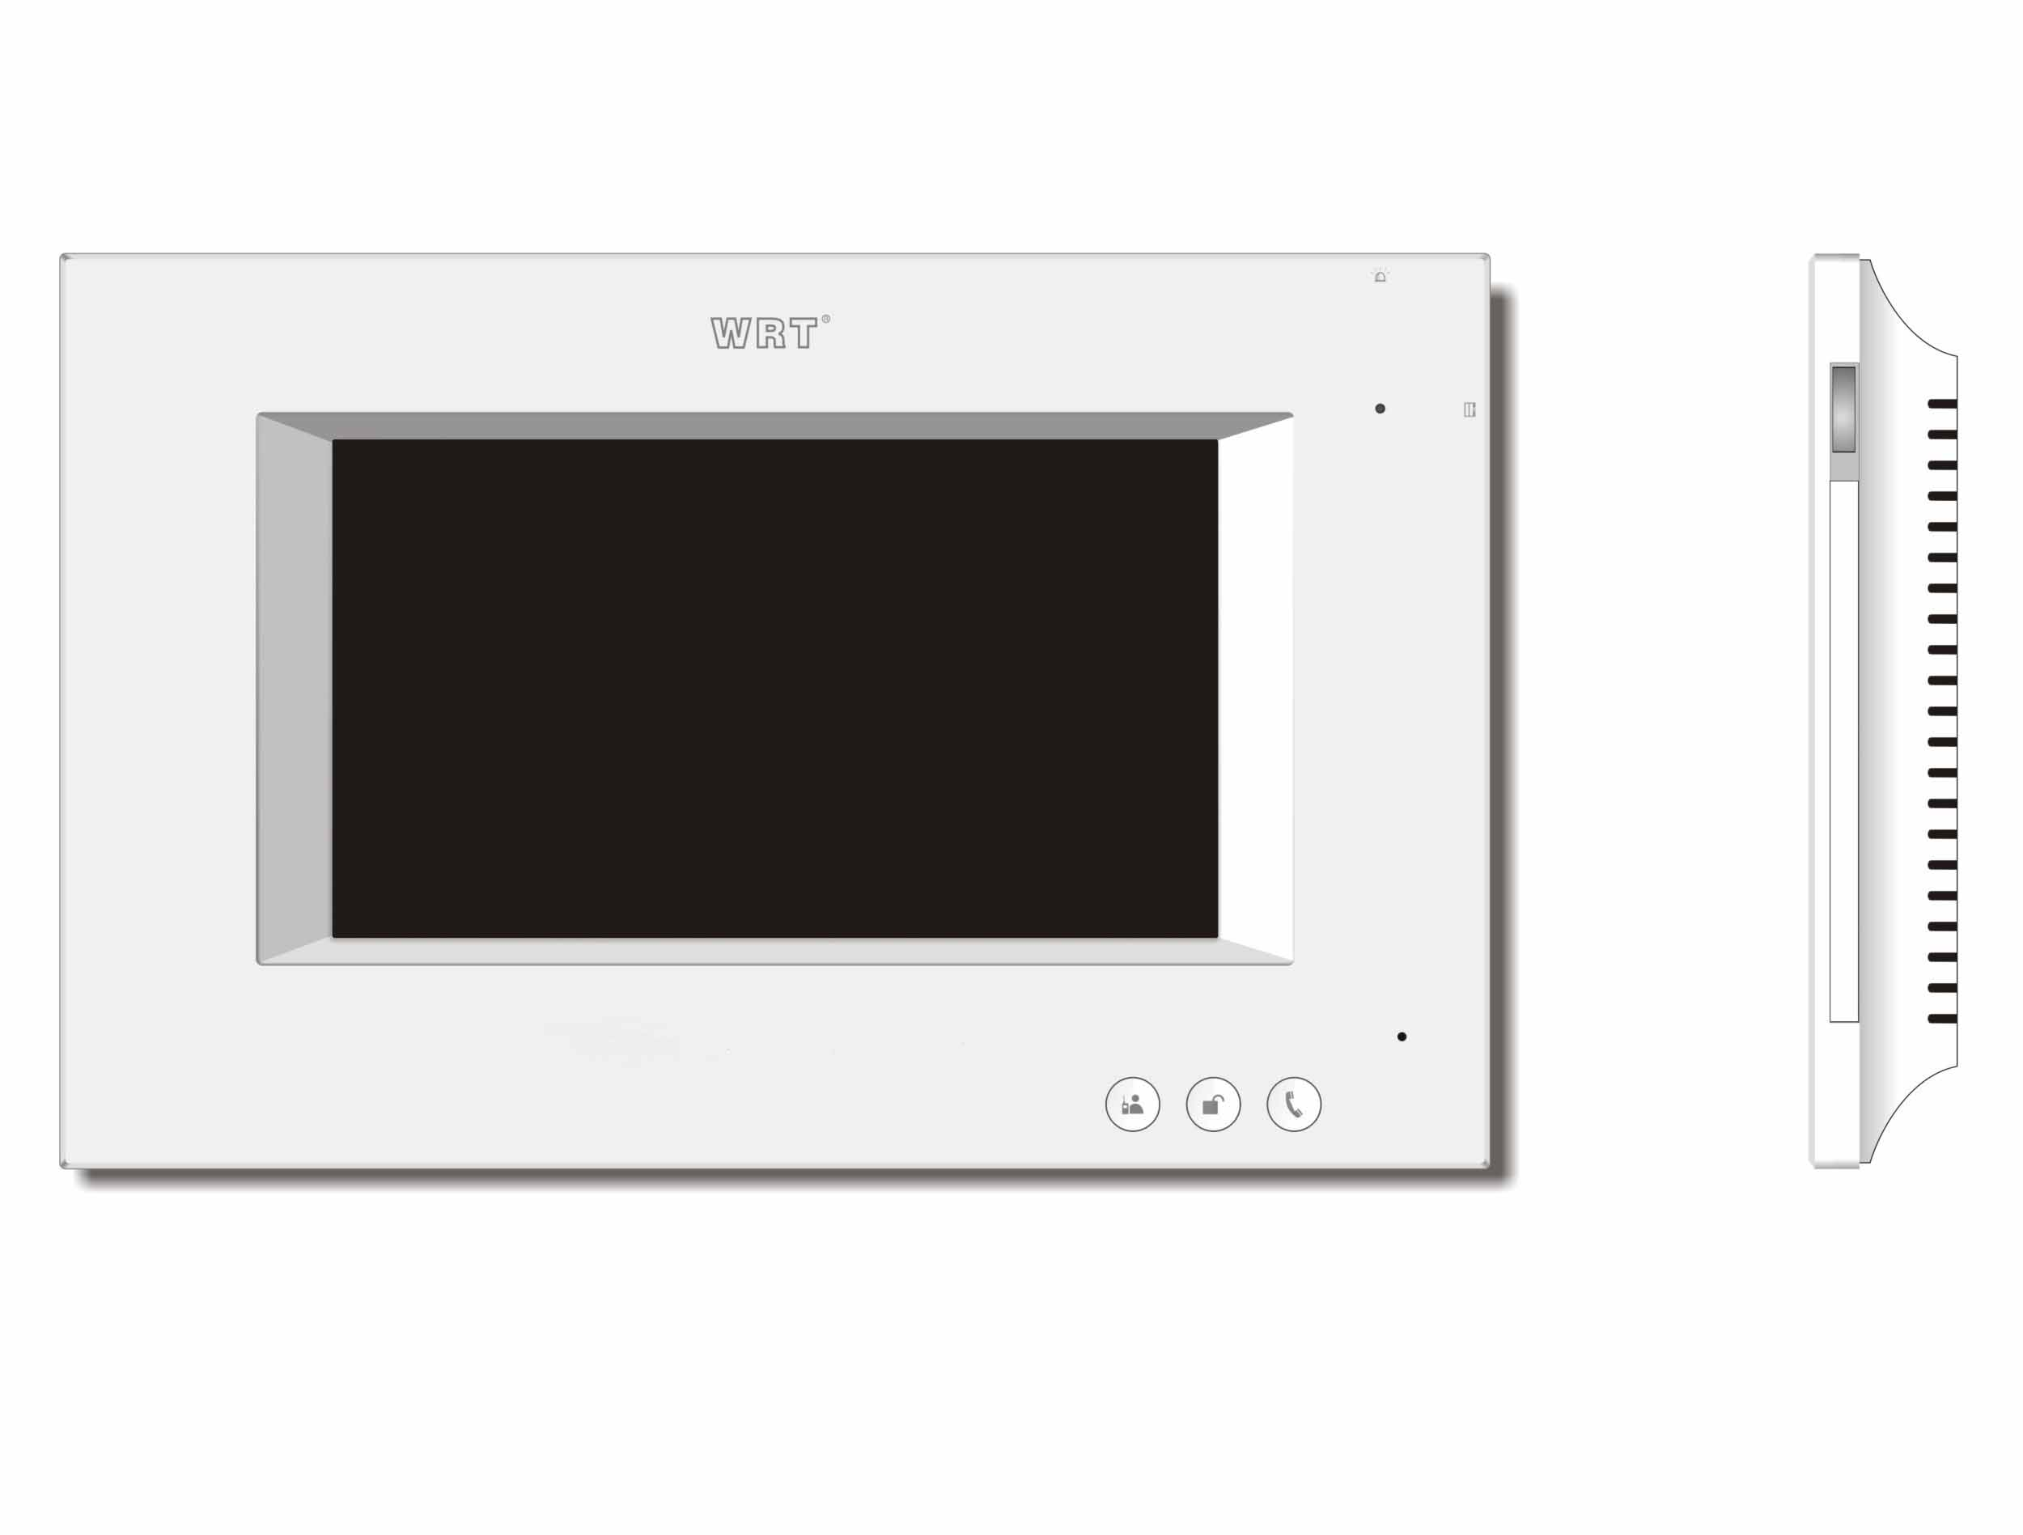
Features:
1.Suit for large community.
2.Wall hanging install, Touch operation .
3.7.0'LCD Display, monitor the situation of the entrance, remote unlock
4.Can call the Control Center, send the emergency to Control Center
5.Call the other tenant for intercom, Bidirectional video
6.Ringtone Download and Silent Mode.
7.Function for lift
8.Call Divert
9.Eight arm/disalarm zones
10.Wireless home furnishings control(For version of D,Z,H)
11.Check pictures, SMS etc.
12.Service for the convenience of the customers from the Control Center is
supported.
13.Parallel Operation is allowed, at most 4 indoor Monitors can be work
together
14.Remote update
Specifications:
Voltage Input----------------------------------------------------------+18VDC/+28VDC
Humidity-------------------------------------45%～95%
LCD-------------------------------------7.0"Color LCD
Sensitivity-------------------------------------≤20mV
Distortion-------------------------------------≤5%
Back Light------------------------------------- Build-in

Standby Current-------------------------------------≤250mA(LCD close)
Working Current-------------------------------------≤300mA
S/ N Ration-------------------------------------≥70dBA
Operating Temperature--------------------------------------10°C～+55°C
Visual Angle-------------------------------------70/75/75/75
Signal Input------------------------------------- MP4/H.264/G.711 Streaming Media
Power output-------------------------------------≥500mW
Number of Pixels-------------------------------------800(H)×3(RGB)×480(V)
Screen Size------------------------------------- Diagonal17.5cm(7.0")
Monitoring time-------------------------------------30s
Communication time------------------------------------- Maximum120s
Network Port------------------------------------- Rj45
Way of Transmission------------------------------------- TCP/IP
Transfer Distance------------------------------------- Decoder or router with100m, add a fiber optical transceiver beyond 100m
External Dimensions-------------------------------------250×160×28mm

