Guard station
Model No. BZG-801C
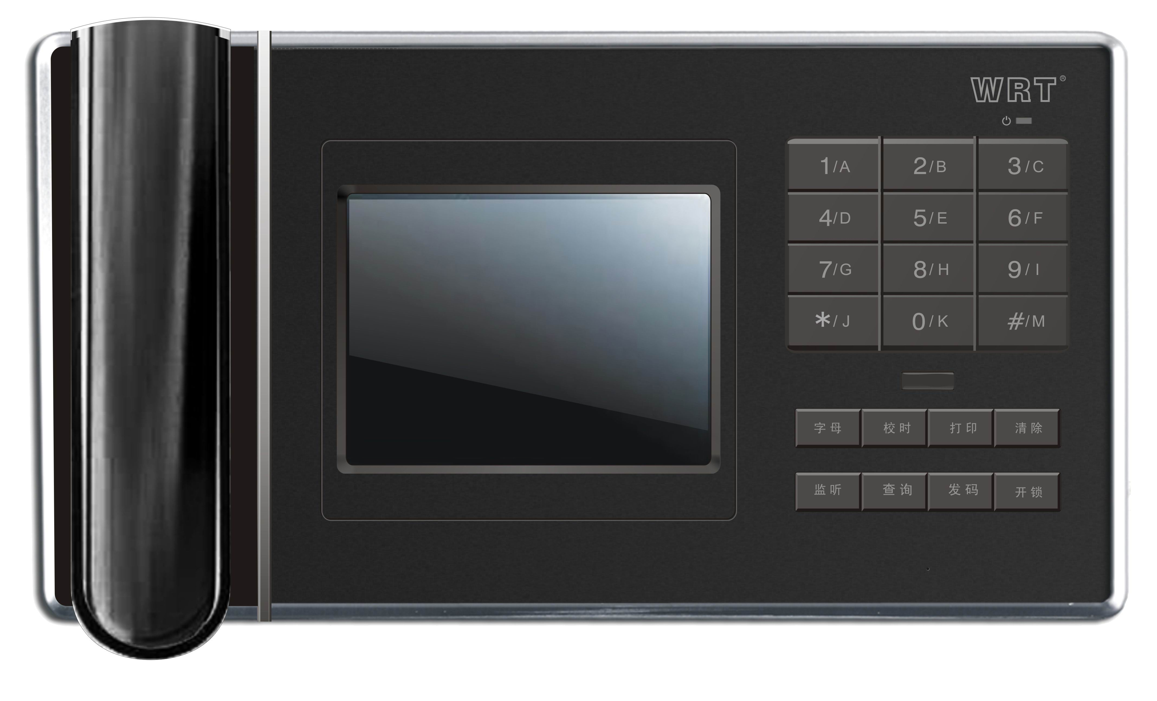
Features:
1.5.6" TFT-LCD,monitor entrance situation
2.Remote unlock to electric lock .
3.Intercom function with gate stations,sub gate stations,entrance stations
4.Monitor each gate station,sub gate station and entrance station
5.Receive alarms or calls from residents
6.Display and record alarm time,location
7.Store 1000 groups alarming address information in loop.
8.Menu for operation instruction
9.Multiple guard stations can work together in the whole system
10.Self-protection function when power is off,keep all data for the system.
11.Support remote update

Specifications
Maximum capacity: 9999 gate stations
Intercom time：max. 2 minutes
DC voltage：DC15V/DC18V
Output power：≥50mW
Quiescent current：≤500mA
Dimension：340x185x100mm
Network port：RJ45
Network transmission mode:TCP/IP
CPU: 32-bit processor
Working humidity：45%～95%
Working temperature：-20℃—55℃
Transmission range: router or PBX less than 100m, FOT more than 100m

