Gate station
Model No.IZM-801CS4
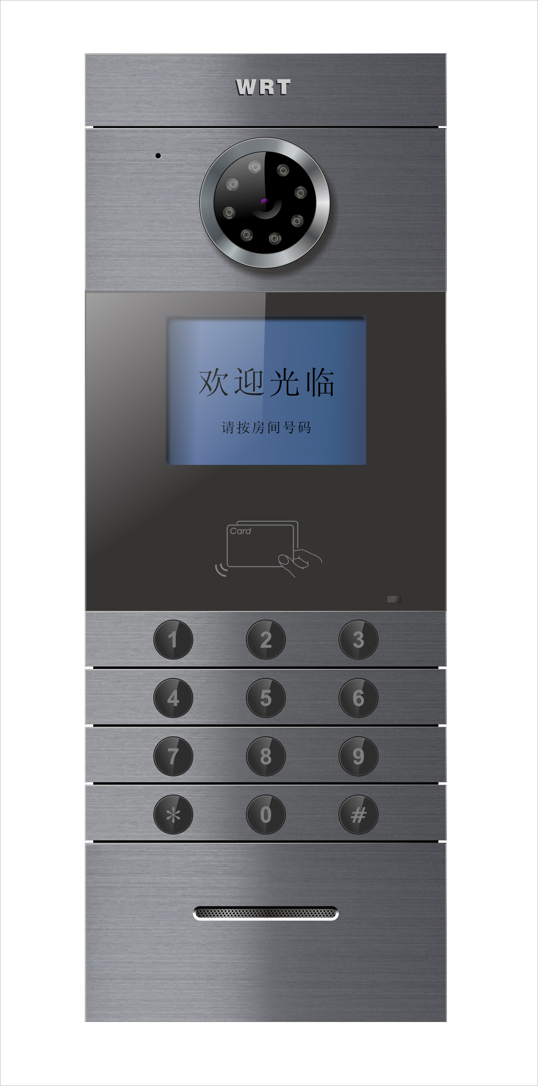
Features:
4" TFT-LCD screen with operation menu
Digital video / audio coding,multi-channels
Call directly to guard station and door phones
Password unlock
IC/ID card unlock
photo snapshot (optional function)
Vandal proof design
Lift control(optional)
Language exchange(Chinese,English)
Picture snap function(optional)
Intimidated unlock alarm function
Door contact alarm function
CCD infrared night vision compensation
TCP\IP protocol with network function, support remote upgrade.

Specifications:
- Display: 4”TFT-LCD
- Working temperature:-30℃-55℃
- Working humidity: 45% - 95%
- Working current: ≤400mA
- Quiescent current: ≤250mA
- Input Voltage: +DC18V
- Protection grade: IP33
- Conversation time: About 120s
- Camera:1/3 inch CCD
- Resolution: 420TV Line
- IC/ID card reading distance: ≤30mm
- Network transmission mode: TCP/IP
- Cable requirement:1*CAT5 8-core cable,1*RVV3 X 1.0mm as power cable.
- Network Port:RJ45
- Transmission range: router or PBX less than 100m, FOT more than 100m
- Size of Bottom Case:147*393*80mm
- External Dimensions:130*378*65

