WRT-VFP4 Signal amplifier Manual
A1
1.Brief Introduction：
1．Suit for the Elite series security system.
2．With 1 input and 4 output.
3．The ports are independent，so if there is problem in one of the four ports, the operation of the other ports will not be influenced.
4．door phones and decoders are connected with RJ45 connectors.
5．When bus input with signal, the signal indicator light would be red.

2.Parts Description：
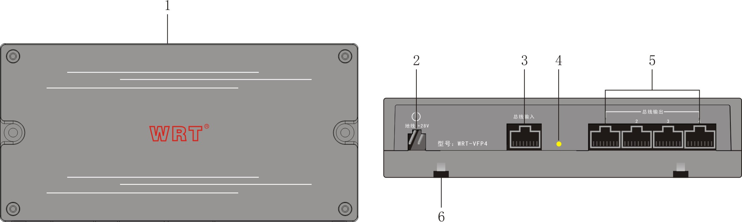
１………………...Cover
２……………….. +28V DC voltage input
３………………...Bus input port（connect with Gate Station）
4…………………Indicator light
5…………………Bus output port（4 decoder）
6…………………guide rail lock block

3.Installation:
Two installation methods : 35mmDIN guide rail installation or use 2 screws to fix on the decoder
1．If using guide rail installation, purchase the matched household power distribution box, then install the guide rail into household power distribution box , and finally install the Signal amplifier on the guide rail.
2．If using screws installation，press the Signal amplifier to register the spacing of screw holes, dig 2 screw holes horizontally on the wall at the height of 167.0mm above the ground, put flexible plug inside the screw holes . Make the Signal amplifier be aligned with the screw holes, and tighten the screws.
3.Cut off the power when installing.
4.After connecting all the wires and confirming there is no problem,then power on.
5.When there is any problem after powering on ,please cut off the power and check. When problem appears,please check the devices and the wiring carefully and if you don't know how to solve the problems,please contact the after sales service department of the suppliers.Do not fix and exchange the parts without instruction.

4.Operation：
１．When the decoders of a building more than 20，add more Signal amplifier to strength transmission capability of signal .
2．Socket SW1,SW2,SW3,SW4,correspond to door phone No.1,2,3,4.When the line is long, signal is weak, unplug and plug each 2 row pin status to adjust the signal.
- UTP5 cable is adopted in the system.The cable must comply to the International Standard(T568B),the making of RJ45 must follow the following order:
1 2 3 4 5 6 7 8
W-O O W-G BL W-BL G W-BR BR
5.Specifications：
Max capacity------------------４output about 80 decoders
Input voltage------------------+28VDC
Quiescent current------------------≤40mA
Working currency------------------≤60mA
transmission band------------------32Hz—62MHz
Transmission distance------------------to gate station about 50m;to farthest
decoder about 100 m.
Dimensions------------------180.0x90.0x40.0mm

